Valentin Vasilev PC05

1. How do your meetings typically proceed? What has been effective, and how could you improve your meetings?
2. How much do you feel you can rely on your group members to complete the required task(s)?
3. How are decisions made in your group? What has been effective , and how could your decision-making processes be improved?
4. Who has emerged as the leader in your group?
5. Which other roles do you see team members taking on?
6. Which role(s) do you play? Which role do you prefer and why?
7. To what extent does your group reflect on how well your goals are being achieved?
8. What happens if a group member is unhappy or uncomfortable with a decision made by the group?
9. Whenever we face a problem we need to resolve we just propose a solution if we can think of one and work on it.
10. I can rely on them, I believe we can all rely on each other.
11. Decisions are usually made by the one who takes the initiative and if someone disagrees we reconsider our choice and try to do the most practical solution.

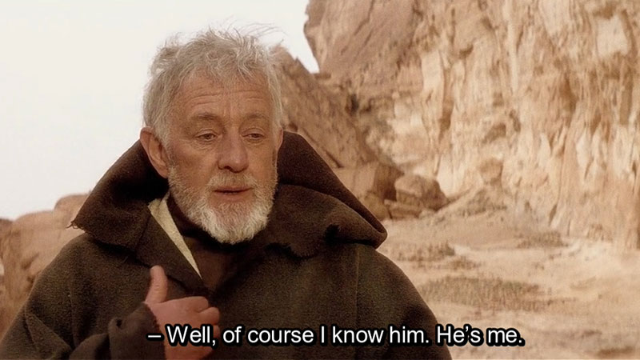

1. They always try with whatever they can to help the other team members and try to spread the workload.
2. I think I am the one who decides how the project will be built, what tools will be used and almost everything else related to the project and how it will be built. I definitely prefer to be the one who decides how and what we are going to do, because I believe I will do it faster and better.
3. We are doing good but are lacking time due to other assignments.
4. We resolve the issue, or reconsider our choice.